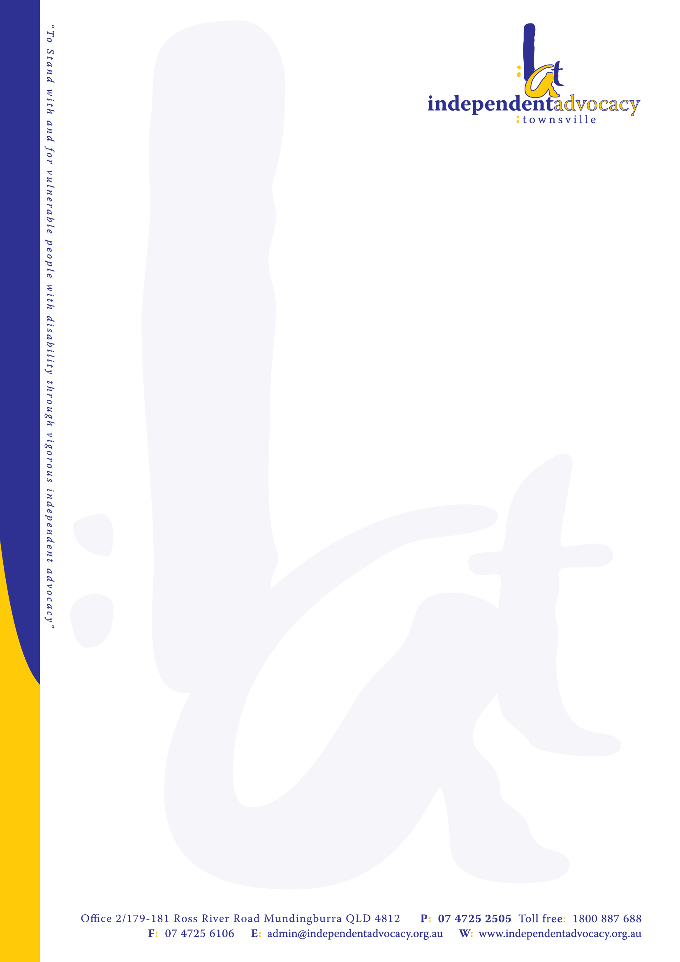
Disability Support Pension
Medical Appeals

If your application for Disability Support Pension has been rejected on medical grounds, you have the right to appeal. This factsheet sets out some information which may help you collect the evidence you need to prove that you satisfy the medical requirements for Disability Support Pension. There are other requirements you have to meet to qualify for Disability Support Pension which are not discussed in this factsheet.

What are the medical criteria for Disability Support Pension?
To be eligible for Disability Support Pension you must:
- score at least 20 points under the “impairment tables”;
- your medical conditions do not receive any points unless they:
  - have been fully diagnosed, treated and stabilised; and
  - are unlikely to significantly improve with or without reasonable treatment within the next two years.
- have a continuing inability to work: ie you must be unable to work more than 15 hours per week for the next two years; and
- have actively participated in a program of support, unless exempt from this requirement.

The 20 points requirement
Many claims are rejected because Centrelink award less than the required 20. If this happens, it is a good idea to look at the impairment tables and see whether or not you (and your doctor) agree this is the correct decision, or whether there are any other points, under a different or the same table, which ought properly to be allocated to your conditions.

The current tables are available publicly on the internet at:
http://www.comlaw.gov.au/Series/F2011L02716

If you don’t qualify in total for 20 points across these tables, you won’t qualify for Disability Support Pension.

If you can identify a table number under which you ought to be awarded points, and/or you think you should be awarded more points for your condition than Centrelink have assessed for you then we suggest you show these tables to your treating doctor and ask them to confirm the number of points, and the table number these should be allocated under.

This is not your doctor’s main job and they may not be willing to write such a letter. It is up to you to ask them whether they would be willing to help in this way. It may help them if you can point them to the tables you believe you score points under.

No points: not diagnosed
No points are awarded if Centrelink finds your condition to have not been “diagnosed” at the time you claim Disability Support Pension or soon after.

For mental health conditions, you need to have a diagnosis from either a psychiatrist or clinical psychologist. A diagnosis from a registered psychologist is not enough. If you have been seeing a registered psychologist or general practitioner for mental health problems, but have not seen a clinical psychologist or psychiatrist by the time you lodge your Disability Support Pension claim, you should ask for a referral to one as soon as possible. When you see the clinical psychologist or psychiatrist, you should take any reports or other documents relating to your medical history to your appointment and ask them:

- to confirm your existing diagnosis and whether or not, in their opinion, it is a longstanding condition; and
- whether any new treatment they suggest is being undertaken with the goal of preventing your condition from worsening, or with a view to your condition getting better; and
- whether any new treatment they suggest is likely or unlikely to result in significant functional improvement to a level enabling you to undertake work in the next two years.

If you only see a clinical psychologist or psychiatrist for the first time after you claim the Disability Support Pension, you may need to appeal any Centrelink decision to reject your claim and lodge a new claim for Disability Support Pension with Centrelink. You can do both at the same time.

No points: not fully treated and stabilised
No points are awarded if Centrelink finds your condition to be not fully treated and stabilised.
If any condition you have was not awarded points because it was “not fully treated and stabilised” you could ask your doctor in particular to comment on:
- what treatment has occurred in relation to your condition (and when this treatment occurred);
- what treatment is continuing or planned for the next two years;
- whether any new treatment they suggest is being undertaken with the goal of preventing your condition from worsening, or with a view to your condition getting better; and
- whether any further reasonable treatment is likely or unlikely to result in significant functional improvement to a level enabling you to undertake work in the next two years.

Continuing inability to work
Centrelink sometimes reject a claim on the basis that a person does not have a continuing inability to work
– that they could work for 15 hours or more a week with appropriate support, or do a training activity to prepare for work, within the next two years.

If your claim was rejected on this basis, it would help if you could get one of your doctors to comment on this issue in writing. In particular, they should comment on the impact of your conditions on your ability (within the next two years) to:
- regularly report to work;
- persist at work tasks;
- understand and follow work instructions;
- communicate with others in the workplace;
- travel to/ from work;
- move around at work;
- attend to personal care needs in the workplace;
- manipulate objects at work;
- exhibit appropriate behaviour at work;
- undertake a variety of tasks and to alternate between tasks; and
- lift, carry and move objects at work.

If possible, if they could also comment on:
- what level of assistance (low, moderate, high) you would need to maintain any kind of employment; and
- the impact of your conditions on your ability to undertake any training activities to prepare you for work.

The program of support requirement
To show that you have actively participated in a program of support, you need to show that in the three years before you claimed the disability support pension:

- you have been with a program of support for 18 months;
- you have completed a program of support; or
- you were with a program of support which was terminated because your medical conditions alone meant that continuing wouldn’t improve your capacity to find, get or stay in work.

You can also show you meet this requirement if:
- you were with a program of support when you claimed the disability support pension, but continuing would not help improve your capacity to find, get or stay in work. If your provider disagrees with you on this, you have the right to get medical evidence from your doctor.

The requirement does not apply if you have a “severe” disability or illness which gives you 20 points under a single impairment table.

A program of support means a program designed to assist a person in preparing for, finding and keeping employment. It includes using a Job Services Australia provider, an educational or vocational program, or a program specifically for people with a disability, eg, Disability Employment Network and Vocational Rehabilitation programs.

A program of support can include a provider authorized by a workers compensation authority. If you attempted to return to work following a workers compensation claim, for example, you should ask them for a letter confirming your participation and the length of time you were engaged with them with the goal of addressing barriers to employment, or in looking for work.

If you are appealing to the Social Security Appeals Tribunal (SSAT), bear in mind that it is up to you to show that you have met this program of support requirement by showing evidence of the dates you participated with a program of support. Centrelink often do not give the SSAT evidence to show that you have met this requirement. Centrelink have a standard form which you could use to ask any former provider for information about your past experience with them, which is available here:

Information about participation in a program of support form

Appeal rights
If your Disability Support Pension Claim has been rejected, you have 13 weeks in which to appeal. To appeal simply tell Centrelink that you are not happy with their decision and that you would like to appeal to an Authorised Review Officer (ARO). If you have already had a decision by an ARO, you have the right to appeal further and you need to do this within 13 weeks of the ARO decision.

To best support your appeal you need to check which part of the qualification criteria you did not satisfy to see what you will need to get supporting evidence about. If you are not sure, you can use the sample letter attached to address all aspects of qualification.

Gathering the evidence you need to prove your qualification for Disability Support Pension can be exhausting and frustrating for many people with disabilities. However if you do not produce any new medical evidence since the last decision Centrelink made about your claim, the decision on appeal will likely be the same decision.

In some cases, as well as lodging an appeal (or instead) you may need to lodge a new claim as well. This is because the decision maker looking at your appeal can only look at your medical condition from the time you claimed and during the 13 weeks after your claim. You may need go lodge another claim if:

- there has been any change in your medical condition, if there might be a problem getting a doctor to say what your condition was during this timeframe, or where Centrelink have raised any issue about whether
- your condition is fully treated, diagnosed or stabilised.

If your claim has been rejected for Disability Support Pension, you may be receiving an activity tested payment like Newstart Allowance while your appeal is on foot.

PLEASE NOTE: This factsheet contains general information only. It does not constitute legal advice. If you need legal advice about your social security entitlement, please contact your local Community Legal Service or advocacy agency. They are entirely independent of Centrelink.
Sample of letter to give to your doctor

[Date]

Dear Doctor

I need to obtain a Disability Support Pension.

To be qualified for Disability Support Pension, I must:
- have a physical, intellectual or psychiatric condition that has a rating of at least 20
- points under the impairment tables; and
- be fully diagnosed, treated and stabilised, and my condition must be unlikely to significantly improve, with or without reasonable treatment, within the next two years; and
- be prevented, because of my impairment, from working more than 15 hours per week for the next two years; and
- be prevented, because of my impairment, from undertaking a training activity that would equip me to work 15 hours per week within two years, independently of a program of support.

Unless I score 20 points under a single impairment table, I will be required to go on
Newstart Allowance and try to find work or do a training activity with the help of a program of support for a reasonable period of at least 18 months.

It would be helpful if you could write a brief letter that addressed my situation in relation to the above criteria, namely:

- How many points, in your opinion, I should receive according to the enclosed impairment table(s).
- Whether my condition has been fully diagnosed. Please specify what treatment you are giving me for each of my conditions.
- Whether the treatment I am currently receiving, or any treatments reasonably available to me are likely or unlikely to make a big difference to my condition to the point that I could work for 15 hours a week or more within the next two years.
- Whether you think my condition is likely to get better, stay the same or get worse in the next two years (including with the treatments I am currently receiving or likely to receive).
- Whether you think I am unable to do any type of work for 15 hours a week or more over the next two years.
- Whether you think my medical condition means that my participation with a program of support program is likely or not likely to improve my capacity to find, get or stay in work.

Please address the letter “to whom it may concern” as I will likely be forwarding this letter to Centrelink and / or the Social Security Appeals Tribunal.

I thank you sincerely for your time and assistance in this matter.

Yours faithfully,

[signature and name].

Sample of letter to give to a provider / former provider

[Date]

Dear provider / former provider,

I would like you to provide me with a letter that accurately advises Centrelink of information about my participation in your program.

Please could you set out in writing:

- Details of your program of support;
- The dates I am / have been registered with your program – when I started and when I finished;
- If I finished or was terminated: the reason why – in particular:
- did I complete the program?
- was it because my state of health meant that continuing with your program would not improve my capacity to find, get or stay in work?
- If I am currently still registered with your program: whether you think that continuing would not improve my capacity to find, get or stay in work because of my state of health;
- Any periods I was not able to participate in your program including exemptions, reliefs of suspensions, and the reason for these periods;
- The terms of the program that were tailored to address my level of impairment, individual needs, barriers to employment and capacity to work;
- The terms I had to comply with to satisfy those program requirements and my level of compliance with those terms;
- The vocational, rehabilitation or employment activities I participated in as part of the program; and
- The frequency of contact that I had with you as my provider during the times I was with your program.

Thank you for your help.

Yours faithfully,

[signature and name].

