Independent Advocacy in the Tropics Inc.
Accredited Disability Advocacy Service
Office 2, 179 – 181 Ross River Rd
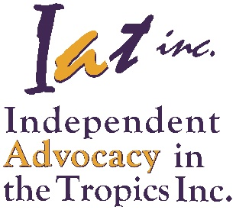
Mundingburra Qld 4812
PO Box 3065
Hermit Park Qld 4812
Phone: 61+ 7 4725 2505
FreeCall: 1800 887 688
Fax: 61+ 7 4725 6106
Email: reception@ianq.org.au
Website: www.ianq.org.au

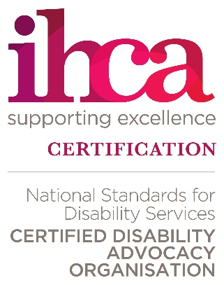
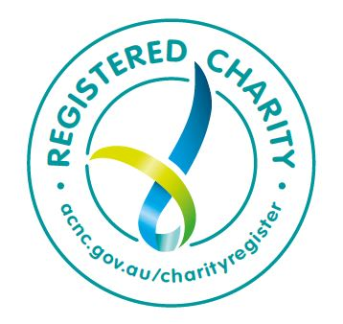
Accreditation
National Disability Advocacy Standards
Individual and Systemic Disability Advocacy

Vision Statement
“A world of equality, justice and choice.”
Mission Statement
“To stand with vulnerable people with a disability through vigorous, independent, advocacy.”

Who are we?
Independent Advocacy in the Tropics Inc (IATI) including all its registered Business Names, is a not for profit organization that provide accredited disability advocacy services to people with disability in North Queensland.
We hold accreditation for both individual and systemic advocacy under the National Disability Advocacy Program. Our services are delivered free through bulk funding from the Department of Social Services, the Department of Communities, Child Safety and Disability Services and Queensland Health.

What do we believe?
People with a disability are in particular need of advocacy because they often experience or are vulnerable to:
- Discrimination
- Neglect
- Exploitation
- Abuse
All people have the right to:
- Be treated with respect and dignity
- Be valued as individuals
- Participate in the decisions and choices that effect their lives
- Be involved in and contribute to their community
- Safety and protection from abuse, neglect and exploitation
- Live the life they choose

Why do we believe that?
- People with disability are just as valuable as any other human being regardless of what they do or don't do.
- People with disability need the same things that all people need to live well in this world; their own place, sense of belonging, love and affection, safety.
- We are all connected within a community and in our world and people with disability must be fully included in this.
- People with disability should not be separated, segregated or isolated.
- People with disability are human and as such will make mistakes, have courage, be fearful, be likeable, be unpleasant just as any other person.

What do we do?
- Provide confidential and high-quality advocacy that strives for people with disability to achieve personal goals without harmful effect.
- Analyse critically and respond to community attitudes, practices and service models that create dependency and segregation from the community and that impact negatively on people with disability.
- We support individuals with advocacy in ways that are creative, responsive and flexible.
- We undertake systemic advocacy that pro-actively and assertively seeks to influence positive change to policies and procedures that affects the lives of people with disability.

How do we do it?
Functioning by speaking, acting and writing with:
- minimal conflict of interest
- sincerely perceived interests; and by
- promoting the person’s entitlement to equality and justice

Why do we do it?
Not everyone is born free
Free to grab their rights with both hands
Some need to fight
Fight for basic freedom
Fight for the same rights everyone else takes as assumed
There are those impassioned to support us
They become freedom fighters
They may look ordinary
But they are extraordinary
They never take no for an answer
They are Advocates

Self-Advocacy Workshops
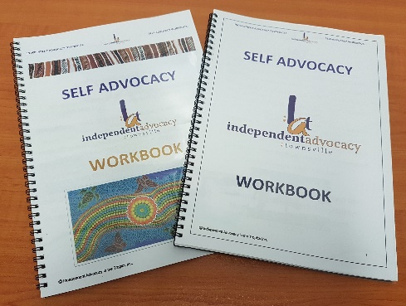
IATI have developed a training package designed for people that addressed the key skills required to be adopted for effectively advocating for yourself. Not limited to only people with a disability but anyone who would like to learn how to better advocate for themselves or their loved ones. Speaking up and advocating for yourself can help someone feel strong and take charge of their life. However, it is not always easy to have the confidence to go for it. Making your own choices, big or small, can make a big difference in how you feel about yourself - help you to find your voice and make informed choices—even when you may not be at your best.
The workshop covers: “What is a Disability” “What are Rights” “What is Advocacy”. Those attending a workshop are broken into groups to discuss amongst themselves and identify how they perceive those subjects. Other subjects covered are Communication Styles, Values, Seeing from the other side, Negotiation and Making a Plan in readiness for the NDIS. Activities and role plays provided education, laughter and a realistic situation.
We are now developing the next Workshop in the series entitled Self-Advocacy and the NDIS. If you are interested in workshops, please contact us at reception@ianq.org.au.

General Advocacy
Here at IATI, we provide accredited advocacy support for children, young people and adults with disability no matter their gender, cultural identity or type of disability.
Some of the types of areas in which we advocate for people are:
- Assistance with government departments;
- Discrimination, harassment and bullying;
- Issues with service delivery and supports;
- Public Guardian and Public Trustee issues;
Our Advocates will also support and be with you with and during:
- Hospitals stays;
- Legal proceedings (ie., through courts and within correctional facilities);
- Administrative Tribunals (AAT and QCAT);
- Mental Health Units and Rehabilitation Centres;
- Mental Health Reviews and in the Mental Health Court; and
- Residential Care Facilities.
There are many other areas in which we can assist and if we are unable to, then we will refer you on to a more appropriate organization for assistance.
While we can be with you through legal proceedings, we are not lawyers so do not give legal advice but we can support you in understanding what is happening each step of the way and in some instances we may be invited to speak directly to the Magistrate or Judge on your behalf.

NDIS and Advocacy
Section 4, Part 13 of the NDIS Act 2013 states:
(13) The role of advocacy in representing the interests of people with disability is to be acknowledged and respected, recognising that advocacy supports people with disability by:
- promoting their independence and social and economic participation; and
- promoting choice and control in pursuit of their goals and the planning and delivery of their supports; and
- maximising independent lifestyles of people with disability and their full inclusion in the mainstream community.
Though advocacy is not covered under the NDIS and we remain block funded, we ourselves have embarked on the NDIS journey to enable us to respond to the changing needs of our clients. We see the introduction of the NDIS as a step in the right direction in enabling those with disability to have a greater ability to access services and their community. It will allow them to have services they need where and when they want it. Life is not 8 – 5 so why should their services be restricted to these hours? Along with this freedom of choice also comes the responsibility of managing their own finances in relation to services. This for many will be completely new to them and with it a different sort of challenge.

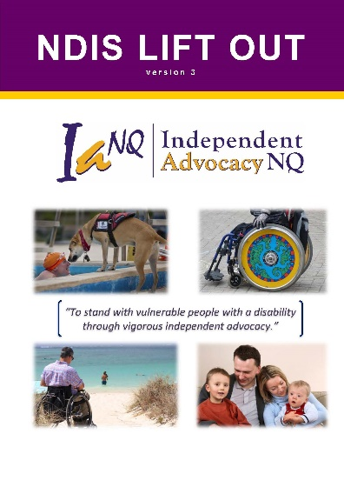
IATI has put together a booklet regarding the NDIS. The NDIS Lift Out (v3) is a handy reference booklet to use when needing to know about the NDIS. It is not meant to be a comprehensive informative tool but something you can use as a guide to point you in the right direction of where to go to get more information.
There are a range of supports available to assist you with decision making. IATI can help you with general access and support issues and can also assist you with issues that may arise with the National Disability Insurance Scheme or with your support providers.
- We can help you to build capacity to identify your needs and goals.
- Ensure that you understand your rights and responsibilities.
- Make sure that you understand your decisions and how they will affect your life.
- Provide support with reviews and appeals. For example, if a decision is made that you disagree with, you can request a review of that decision. In these instances the NDAP can help you participate in the review process. The NDAP can also put you in contact with a support person if you are seeking a review of a NDIS decision in the Administrative Appeals Tribunal (AAT).

Internal Review of a Decision
If you think they have made a wrong decision, you can submit an application for internal review of a decision. Any person directly affected by a decision of the NDIA can request such a review. Many decisions made by the NDIA are reviewable, including things like being accepted as a participant, the provision of reasonable and necessary supports, and becoming a registered provider of supports.
When you are told about an NDIA decision, you will be told how to request an internal review. A request for internal review of a decision must be made within three (3) months of receiving notice of the decision from the NDIA. The staff member who works on the internal review will not have been involved in the earlier decision.

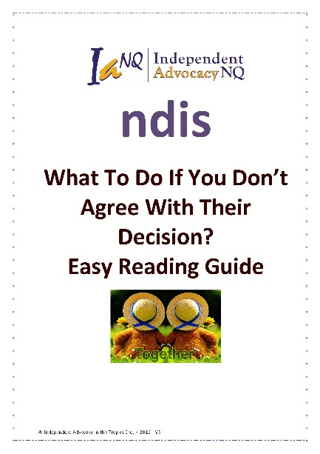
NDIS Appeals
We have been appointed under the NDIS Appeals program (formerly known as the External Merits Review Support Component) to provide advocacy support to those undertaking NDIS Appeals in our NDAP funded regions and also in the Isaac, Mackay and Whitsunday regions. Advocates under this program are known as NDIS Appeals Support Officers.
IATI’s What To Do If You Don’t Agree With Their Decision? Easy Read Guide will help you through each process and is available from our office and on our website.

The Work of an Advocate….
(Names are fictional)
Why is it appropriate to celebrate your 50th birthday in a nursing home because there is insufficient accommodation in the community? Why was John removed from his home town because of not having accommodation to meet his needs in his hometown? Is it appropriate to have your fellow roommates pass away in the middle of the night and you not receive counselling for your grief? Your room mates are old enough to be your parents and aunts and uncles. Does this make it okay that you live the life of an aged person before your time? Is it right at the age of 50 you listen to music that was before your time, play bingo instead of going to a football game, be institutionalised instead of living in the community?
Hilary went to hospital because she was sick. Hilary was confined to hospital for eleven months while treatment was constantly postponed. Hilary could have been treated as an outpatient but she was under a legal order and had her rights taken away from her and was not allowed leave the hospital. She could no longer make her decisions, even though she had the capacity to make them. Hilary was also denied access to her money as there was a legal order which assigned an organisation to manage her money. Independent Advocacy, fought for Hilary’s rights and was successful in having the legal orders removed, so she was able to make decisions and manage her own funds. Hilary is having her surgery and can discharge into her choice of accommodation and be treated as an outpatient, which was always her intention.
When 20 year old Tiffany’s family relocated to another state, Tiffany could not move with them as she had no accommodation which could provide her with the level of care she required. Tiffany had no family in Townsville and little friends. She was depressed and would often self- harm. Tiffany also found a way of trying to abscond from her current home. Independent Advocacy fought a long battle to have Tiffany reunite with her family and live close by in appropriate accommodation. Tiffany now lives a life complete…her family, old friends and access to events she enjoys.
Mark was on a Disability pension and acquired a large debt over a period of years which he could not pay back. The debt was in relation to accommodation Mark needed to accommodate his physical disability. Mark suffered depression as well as his physical disability. Constant reminders and letters of demand to repay the debt where a constant concern of Marks and his family….where could he access over $10000 to repay the debt. Independent Advocacy advocated for Mark to have the debt abolished as he was not in a position to repay.
Nathan suffered a mental illness and had a relapse in his workplace. Nathan was taken to hospital and stabilised and medicated. Nathan was finding it difficult to return to work as his employer thought he was a risk to their business. The employer did not want Nathan back and was trying to access his medical records without his permission. The employer was also trying to speak to his Doctor without his permission. Independent Advocacy fought for his rights under Fairwork Australia and Nathan was able to return to work. So long as Nathan takes his medication and recognises when he is becoming unwell, he will be able to fulfil his work duties and feel a valued member of society, contributing and enjoying the same opportunities as others.

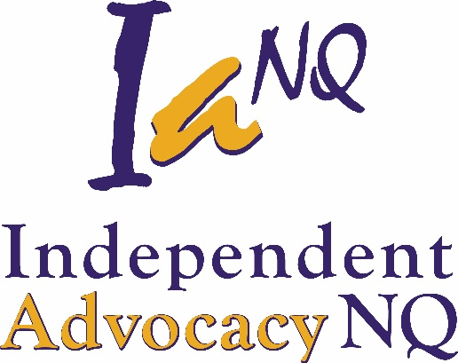
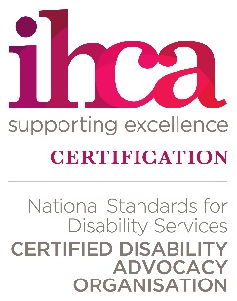
Independent Advocacy in the Tropics Inc.
Office 2, 179-181 Ross River Rd
MUNDINGBURRA QLD 4812
Phone 07 4725 2505
FREECALL 1800 887 688
reception@ianq.org.au
www.ianq.org.au
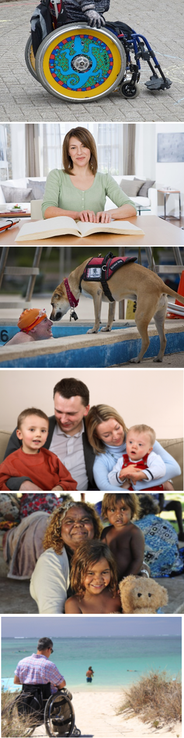
People with a disability are in particular need of advocacy because they often experience or are vulnerable to discrimination, neglect, exploitation and/or abuse.
Independent Advocacy in the Tropics Inc. (IATI) and all its registered Business Names is an organisation formed in 1989 then incorporated in 1991, to provide advocacy for people with disability.
We provide a FREE quality advocacy service to those with disability no matter their age, disability (including living with mental illness), gender, or cultural background.
Here are some of the areas we can assist you with:
- Assist you to be treated fairly and stop abuse
- Assistance with Centrelink, Public Guardian and Public Trustee
- Have your rights respected and promote your best interests
- NDIS planning, complaints and reviews
- Provide self-advocacy workshops
- Speak up for you and protect your dignity
- Support through justice proceedings, correctional centres and parole
- Support through mental health and rehabilitation units and proceedings
If you feel you or someone you know is not being heard, rights are not being met or are being discriminated or exploited, we can help. Our advocates are a phone call away and regularly visit clients throughout our service areas of:
* Burdekin * Cassowary Coast * Charters Towers
* Flinders * Hinchinbrook * Isaac ^^
* Mackay ^^ * Mckinlay * Palm Island
* Richmond * Townsville * Whitsunday ^^

^^Mackay/Isaac/Whitsunday (NDIS Appeals only)
If you live in another part of North Queensland, please contact us.
Independent Advocacy in the Tropics Inc is funded by Department of Social Services, the Department of Communities, Child Safety and Disability Service and the Queensland Health Department.
Accredited Disability Advocacy Service

